Create Sample BRD

Leveraged MS-Copilot to Build the Sample BRD:
- First a Skeleton Strawman
- Second AI Assisted Sample for a Fortune 500 Co. the way they would expect a BRD
- Thirdly, Used the my Client details for Building a Sample BRD.
- Additional BRDs collected and to be given as input for the Agents : Different Level Of Complexities and Scope etc..
Sample BDRs added to the Inputs :

Prompt to Claude.
WHAT? To build a multi-agent system that transforms a raw BRD into a complete set of engineering artifacts — plans, schedules, architecture, PoC scope, and tech-stack recommendations — all grounded in organizational knowledge, validated by a Critic Agent, and evaluated with quality badges before reaching the EM
WHY? Faster turnaround: RAG-augmented agents reference past projects and org templates instead of producing generic boilerplate.
HOW? Standardized, validated planning: A Critic Agent checks every output for completeness, consistency, and alignment before delivery.
- Grounded intelligence: RAG grounds plan and architecture decisions in org standards, past BRDs, and historical project data.
- Evaluated outputs: Outputs carry Green / Amber / Red quality badges — not just generated-and-displayed.
- EM enablement: Decision-ready artifacts with source citations, not drafts from scratch.
Leverage Existing Organization Knowledge Base. Use Samples for the Trainig

HIGH LEVEL SOLUTION:
- All 7 agents => With 2 Workflow Path => Orchestrator + Planning Group + Design Group + Critic
- Implemented above with structured output contracts => Defining output contracts (JSON schemas) between agents with validation at every handoff
- Build Outcome =>
  - Planning Document ( Cost + Timeline+ Resource) +
  - Schedule Document+
  - POC Scope & Approach +
  - Tech Stack Recommendation for Development +
  - Production Level Vendor Map for Tech Stack

Here is the architecture with all 7 agents, the two workflow paths, and the five deliverables.

First Design BY ME
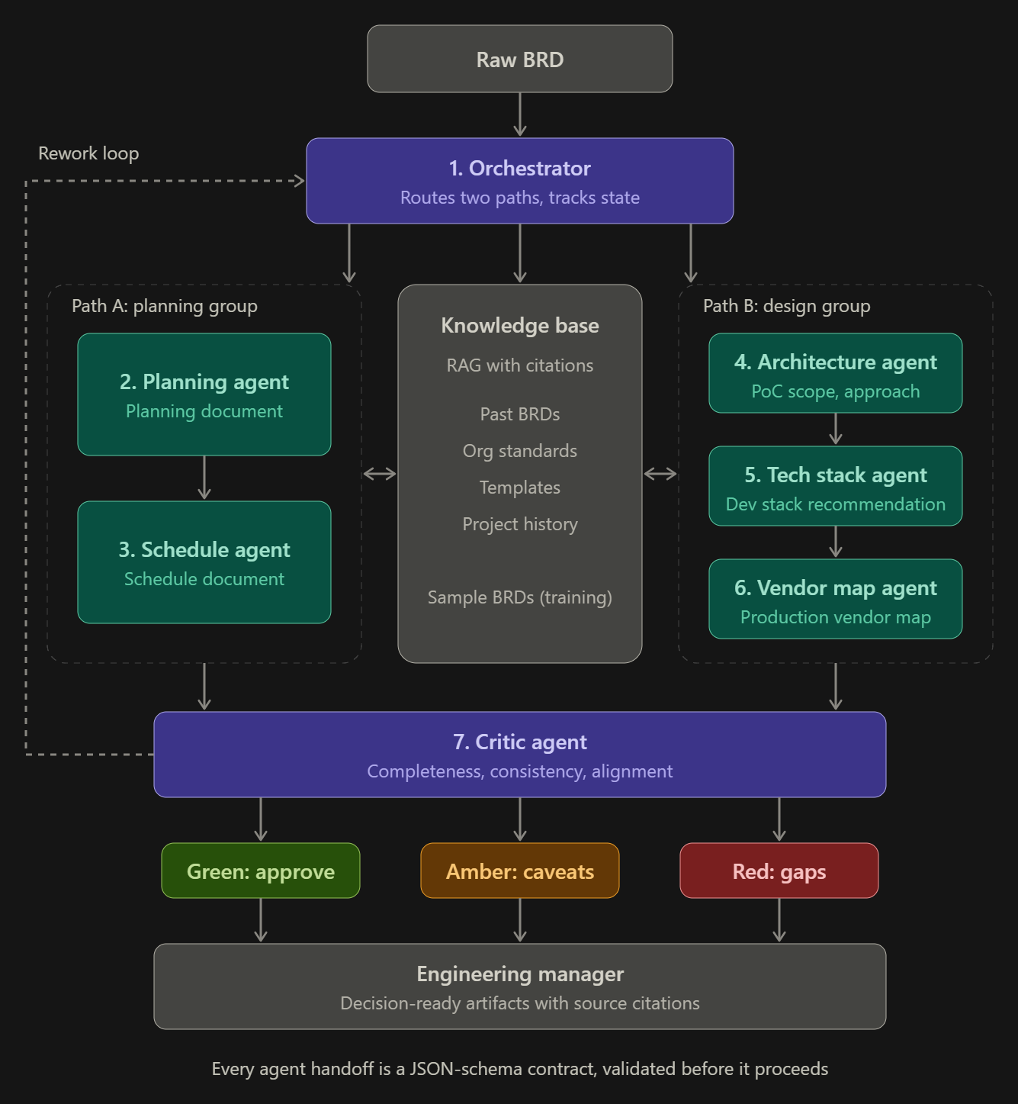

Agent split
The brief didn't name the individual agents, so I split them to match your five deliverables. Please correct this if your intended split differs.
# | Agent | Group | Produces
1 | Orchestrator | Control | Routes the BRD to both paths and tracks state
2 | Planning agent | Path A: planning | Planning document (cost, timeline, resources)
3 | Schedule agent | Path A: planning | Schedule document
4 | Architecture agent | Path B: design | PoC scope and approach
5 | Tech stack agent | Path B: design | Tech stack recommendation for development
6 | Vendor map agent | Path B: design | Production-level vendor map for the tech stack
7 | Critic agent | Quality gate | Validation and quality badge
Design points
- Two paths in parallel: Path A runs planning, then schedule. Path B runs architecture, then tech stack, then vendor map. Both paths read from the same knowledge base.
- Grounding: The knowledge base is a RAG layer over past BRDs, org standards, templates and project history. Sample BRDs are used for training and tuning. Every agent output carries source citations from it.
- Contracts: Each handoff uses a JSON schema, validated before the next agent starts. A failed validation goes back to the producing agent, not on to the next one.
- Critic and badges: The Critic checks completeness, consistency and alignment, then assigns a Green, Amber or Red badge. Green is approved, Amber is delivered with caveats, and Red means gaps. The badge is shown with the output, so the EM sees quality alongside content.
- Rework loop: Red outputs go back to the Orchestrator for another pass. I'd cap this at 2 or 3 retries, then escalate to the EM with the Critic's reasons.
The EM receives decision-ready artifacts with citations and badges, not drafts from scratch.

As per the CAPSTON project :

Agent Architecture & Output Contracts
Your system comprises seven agents. Every agent follows the principle: one role = one job = one output contract. You define the schema that fits your tool track; downstream consumers validate it before proceeding.
# | Agent | Group | Primary Responsibility
1 | Orchestrator | Orchestration | Route BRD sections to specialist agents; manage state; handle errors and retries.
2 | Engineering Plan Generator | Planning | Phases, risks, milestones, team composition. Uses a Reflection self-review step.
3 | Schedule Estimator | Planning | Effort estimates, timelines, resource allocation. Aligns to the plan's phases.
4 | Solution Architect | Design | High-level system design, components, data flow, NFR mapping.
5 | PoC Planner | Design | PoC scope, measurable success criteria, modular boundaries.
6 | Tech Stack Recommender | Design | 2–3 stack options with trade-offs (scalability, team familiarity, integration risk, cost).
7 | Critic | Validation | Score outputs on completeness, consistency, actionability, groundedness. Enforce the revision loop.

Critic behavior. Every output from Planning and Design groups passes through the Critic. If any rubric dimension falls below threshold, the Critic sends specific feedback to the originating agent for revision. Cap revisions at two cycles; beyond that, flag to the EM with an Amber / Red badge. The Critic also checks cross-agent consistency (does the schedule align with architecture complexity? does tech-stack familiarity match the timeline?).

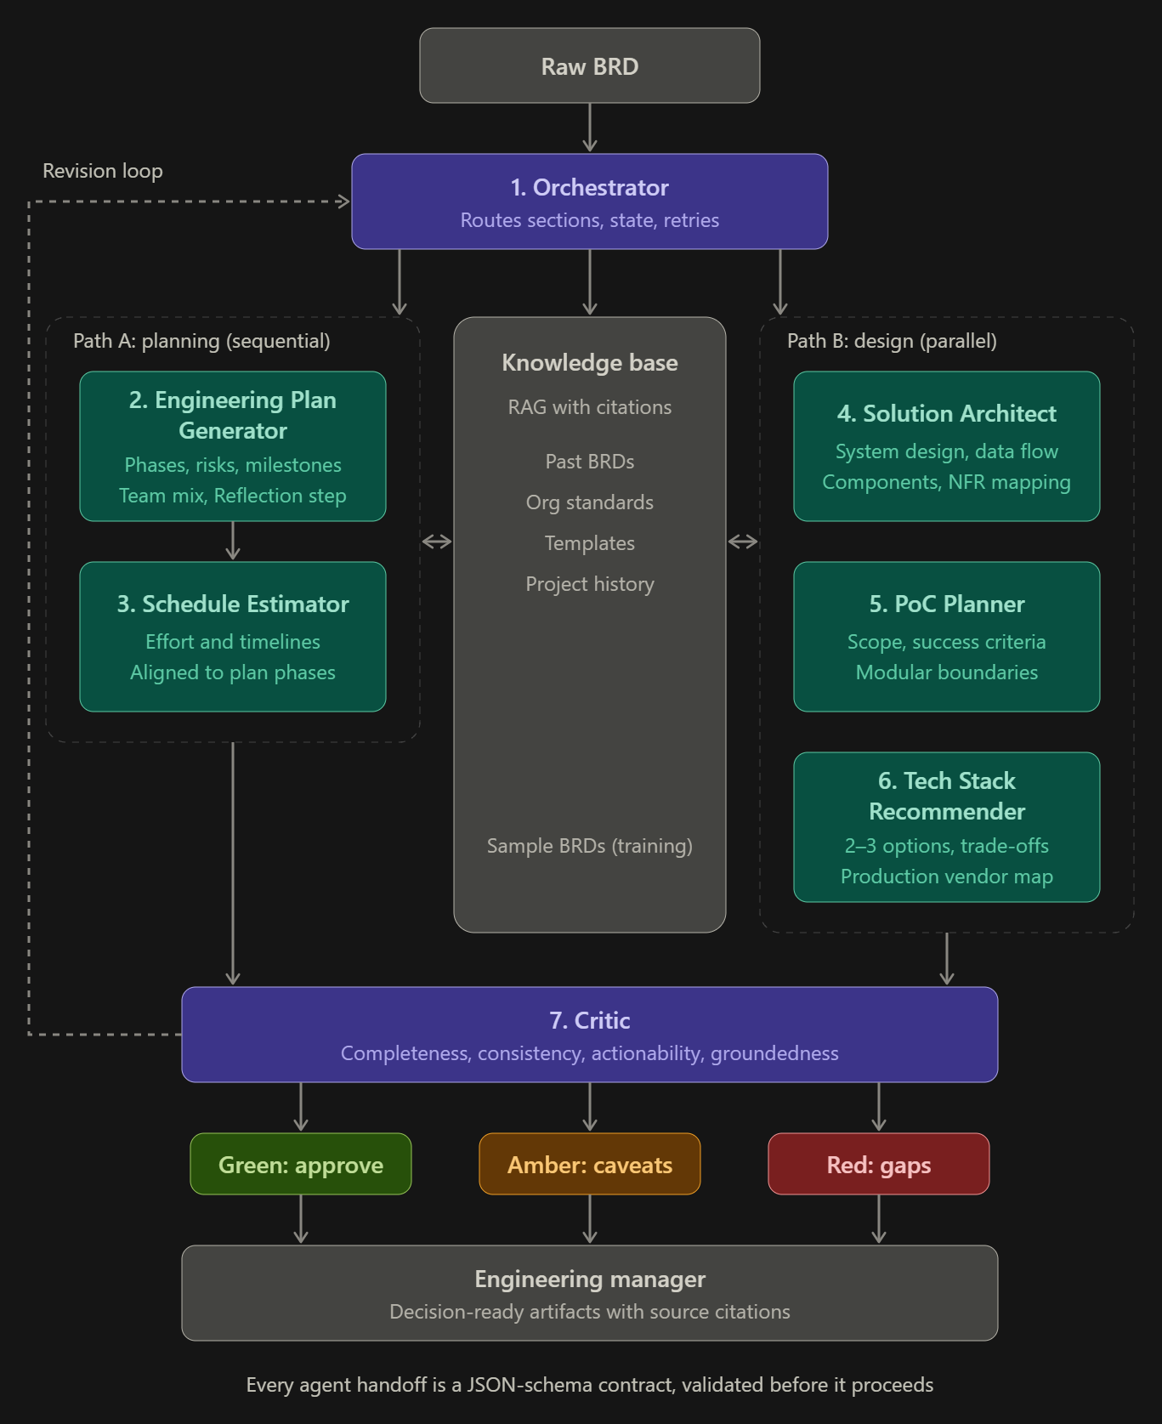

Tool tracks. Low-code (n8n + Langflow) for visual DAGs, or code (Python + LangChain / LlamaIndex / LangGraph) for full programmatic control. The architecture below is tool-agnostic.
Data flow. BRD in → parse → route to specialist agents → retrieve RAG context → generate → Critic review (with revisions) → evaluate → HITL approval → export. You design the exact hand-offs, error handling, and state management.

To build n8n :
Prompt to build with AI :
To build a multi-agent system that transforms a raw BRD into a complete set of engineering artifacts — plans, schedules, architecture, PoC scope, and tech-stack recommendations — all grounded in organizational knowledge, validated by a Critic Agent, and evaluated with quality badges before reaching the EM.
You Build BRD in → parse → route to specialist agents → retrieve RAG context → generate → Critic review (with revisions) → evaluate → HITL approval → export. You design the exact hand-offs, error handling, and state management
# | Agent | Group | Primary Responsibility
1 | Orchestrator | Orchestration | Route BRD sections to specialist agents; manage state; handle errors and retries.
2 | Engineering Plan Generator | Planning | Phases, risks, milestones, team composition. Uses a Reflection self-review step.
3 | Schedule Estimator | Planning | Effort estimates, timelines, resource allocation. Aligns to the plan's phases.
4 | Solution Architect | Design | High-level system design, components, data flow, NFR mapping.
5 | PoC Planner | Design | PoC scope, measurable success criteria, modular boundaries.
6 | Tech Stack Recommender | Design | 2–3 stack options with trade-offs (scalability, team familiarity, integration risk, cost).
7 | Critic | Validation | Score outputs on completeness, consistency, actionability, groundedness. Enforce the revision loop.

Critic behavior. Every output from Planning and Design groups passes through the Critic. If any rubric dimension falls below threshold, the Critic sends specific feedback to the originating agent for revision. Cap revisions at two cycles; beyond that, flag to the EM with an Amber / Red badge. The Critic also checks cross-agent consistency (does the schedule align with architecture complexity? does tech-stack familiarity match the timeline?).

Evaluation Methods (implement at least 2)
- Rule-based: structural checks, schema compliance, BRD section coverage.
- LLM-as-Judge: actionability, specificity, grounding quality, EM-readiness.
- Execution-based: schema parse rates, end-to-end completion, tool-call success.
- Reference-based (code track): ROUGE / BLEU / BERTScore vs. golden outputs.
- Human: EM ratings at the HITL gate.

Dimensions & Quality Badges
Dimension | Threshold
Groundedness — claims supported by retrieved sources | ≥ 75% claims cited
Completeness — all BRD sections addressed | 100% section coverage
Consistency — Plan / Schedule / Architecture / Tech Stack align | 0 contradictions
Actionability — EM can act immediately | Score ≥ 4 / 5

Badges: 🟢 Green (all dimensions above threshold, overall ≥ 4.0) · 🟡 Amber (one dimension below, or overall 3.0–3.9) · 🔴 Red (two or more below, or overall < 3.0).

Guardrails, Safety & Responsible AI
BRDs often contain proprietary business logic. Implement the following guardrails:
- Input validation — reject malformed BRDs; verify file type and structure.
- Schema compliance — validate agent outputs at every handoff.
- Hallucination detection — flag claims not supported by BRD or retrieved RAG context.
- Scope creep — no requirements introduced that aren't in the source BRD.
- Confidentiality — no raw BRD content to external logging. Log hashes, not content.
- Cross-agent consistency — timelines, architecture, and stack must not contradict. Enforced by the Critic.
Handling ambiguity. Ambiguous requirements are flagged in the originating agent's output rather than guessed at. Contradictions are raised to the EM. When forced to choose, default to the more conservative interpretation (lower scope, longer timeline) and document the assumption.

Operationalization & Monitoring
Define success and failure upfront. At least three measurable success criteria and at least three failure modes with mitigations. Examples: completeness check passes on all BRD sections; actionability score ≥ 4 / 5 on the eval dataset; end-to-end pipeline under 5 minutes. Failure modes: malformed JSON (retry then escalate), no RAG hits (proceed with disclaimer + Amber badge), Critic loop stuck (hard cap at 2 cycles).
Logging. For every agent execution, log: input (hashed if sensitive), RAG chunks retrieved, output produced, Critic score, execution time, guardrail triggers, revision count. Use n8n's execution log .

Dt 20-Oct-26
I am working with n8n AI Chat to create – One step at a Time and give specific instructions on what and how to create this Agentic System
- First – Use Diagram to create N8N Canvas and Required nodes of the wworkflow.
Modified the model to gpt-4o-min;
Use only Pythn-3 Cose where needed;
Exception Q ? There is a central knowledge Base; AI recommend to adding that separately in the Individual Path
- Completed Reading BRD as First Node : With the Form Sumbission: Added this node is complete.
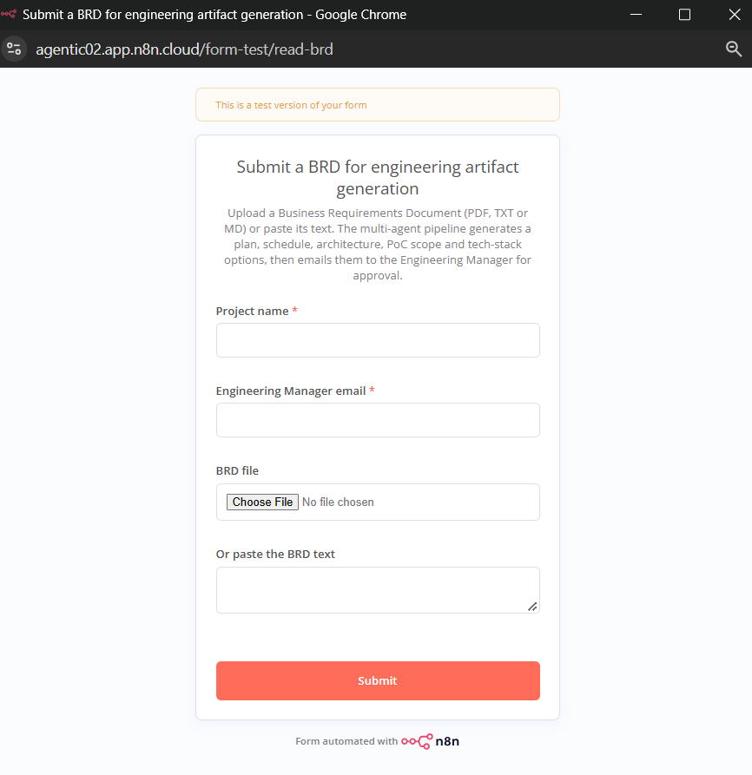

- …How to Build the Orchestrator with the required other areas than just Branching….

COMPLETE SEQUENCE OF ACTIVITIES & FLOW TO BUILD THE AGENTIC SYSTEM FOR (BRD VALIDATION)
- Build Knowledge Repository => Done required samples for BRD, Coding Standard, Past Project Timelines, Engg Plan Template,
Output Artifacts Sample to be added
- Create Agent => What each Agent should do for you to ahieve the expected tasks:
What Prompt
What Knowledge Base
What Model
What Artifacts – Output /
- How respective Agents are communicating
  - What Planner agent should give output to other agent – Parse that as System Prompt
  - What feedback the critic agent should give – parse that as system prompt
  - What out put each agent should provide – include in the Agent Config / System Prompt
- Build Guard Rails:
  - Create System Prompts with : Input validation, schema compliance, hallucination detection, and scope creep prevention implemented. Confidentiality limitations acknowledged.
- Critic Agent : Clarity, Verify Thresholds .. check problem 1.BRD … doc.
  - Apply Evaluation method - LLM-as-Judge or Reference-based (code track): ROUGE / BLEU / BERTScore vs. golden outputs.
  - Human In The Loop: EM ratings at the HITL gate.
- Send Verified Output to Engg Mangaer.
  - What to send – Artifacts
  - Email / message – for decision ready

